Thai-German Technology Conference
Energy Efficiency in Buildings
March 07, 2016
Surasak 1 Room, Eastin Grand Hotel Sathorn Bangkok

Opening
08.30 | Registration
09.00 | Welcome remarks  Marius Mehner, Deputy Executive Director, German-Thai Chamber of Commerce (GTCC)  Dr. Christine Falken-Großer, Economic and Commercial Counsellor, Embassy of the Federal Republic of Germany, Bangkok
Market Development in Thailand and Germany
Keynote Address
9.15 | Chartdanai Chartpolak, Director (tbc)  The Energy Conservation Center of Thailand
9.40 | Ninnart Chaithirapinyo, President (tbc)  Thai Green Building Institute (TGBI)
Energy Efficiency in Germany at a Glance
10.15 | Introduction of export initiative ‘Energy Efficiency – Made in Germany’ and German companies  Falk Woelm, Project Manager  OAV – German Asia-Pacific Business Association
10.30 | Energy Efficient Buildings in Germany – An Introduction  Christoph Mitterer, Chief Engineer  Department Hygrothermics, Fraunhofer Institute for Building Physics
11.00 | Coffee Break and Photo Session with all Speakers
Energy Efficient Building Development and related services
11.20 | Innovative Energy Concepts for Sustainable Buildings in Southeast-Asia  Dr.-Ing. Robert Himmler, Managing Director  EGS-plan International GmbH
11.40 | Energy Efficiency in the Building Management  Volker Massmann, International Sales Manager  Raico Bautechnik GmbH
12.00 | Energy Efficiency and Sustainability of Buildings in Planning Practice  Thomas Gross, Project Manager International Projects  iproplan Planungsgesellschaft mbH
12.20 | Q & A
12.30 | Lunch

Controlling Technologies for Buildings in Thailand
13.40 | An Energy and Carbon Rating Scheme for Residential Buildings in Thailand (tbc)  Prof. Dr. Surapong Chirarattananon  The Joint Graduate School of Energy and Environment (JGSEE, KMUTT)(tbc)
14.00 | Energy Efficiency Through Voltage Management – Made in Germany(tbc)  Peter Leithäuser, Production Manager  Schuntermann Transformatoren GmbH
14.20 | Welcome to Hora world – Control valves Made in Germany for the energy-efficient climatization of buildings  Jens Lang, International Sales Manager  HORA - Holter Regelarmaturen GmbH & Co. KG
14.40 | Q & A
14.50 | Coffee Break
Energy-Efficiency Solutions for a Better Tomorrow
15.10 | Introduction to Chulalongkorn University’s Building Energy Management (CU-BEMS)  Asst. Prof. Dr. Wanchalerm Pora  Faculty of Engineering, Chulalongkorn University (tbc)
15.30 | Energy Management & Energy Efficiency Innovation  Klemens Jagieniak, Project Engineer, Energy- and Quality Manager  Envidatec GmbH
15.50 | German Water Technologies: Energy efficient automatic safe water supply  Johann Wolfgang Kraus, CEO  GWT German Water Technologies Ltd. (on behalf of Protoplan GmbH, München, Germany)
16.10 | Q&A
16:30 | Wrap-up and Closing of Conference
Meet the Speakers
16.40 | Networking and Individual Meetings
17.15 | End of Conference

Moderator: Timo Prekop, Executive Member of the Board, OAV - German Asia-Pacific Business Association

Company name
Participant name |  |  |  |  |  | Position
Tel |  |  |  | Fax |  |  |  |  | Mobile
Website |  |  |  |  |  | Email

EGS-plan GmbH:
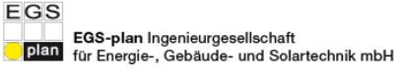
The guiding principle of EGS-plan is manifested in sustainable building design. The building concepts are designed to impact the environment as little as possible and to conserve resources. EGS-plan is part of the MNF (Manfred Norbert Fisch) Innovation network, which combines university research and engineering in the area of energy and building technology in a unique way. EGS-plan is a global company that worked on over 1000 projects worldwide.

Website: http://www.stz-egs.de/home/?lang=en

Envidatec GmbH:

Internationally operating company that offers energy management systems and energy monitoring solutions. Founders are Thomas Frank (responsible for international sales) and Peer Schub (responsible for national sales) Main feature of the product range is the open source software JEVis System, a system for energy and operational data storage and monitoring.

Website: http://www.envidatec.com/index.php?id=79&L=1

Raico Bautechnik GmbH:
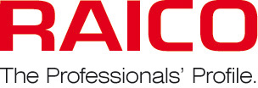
RAICO Bautechnik GmbH develops and distributes high-quality glazing systems for curtain walls, aluminum windows, aluminum doors, and conservatories. Their products THERM⁺, FRAME⁺, WING and CLIMA set the standard in designing curtain walls, windows, doors, glass roofs and conservatories. Raico Bautechnik is a technology leader in this industry, with long-term experience in metal engineering. Its comprehensive portfolio of innovative products and services enables it to fully meet customers' manifold needs and individual requirements.

Website: http://www.raico.de/en/index.php?id=1002

Hora (Holter Regelarmaturen GmbH & Co. KG):
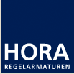
HORA presents itself as a medium-sized, independent, family-owned company satisfying specific customer requirements with two divisions. In its division “Power Technology” it focuses on power plant technology and in its division “Flow Control” it focuses on building and industrial automation. The HORA brand is increasing its operations both domestically and overseas. The “HORA Power Technology” division encompasses products

ranging from control valves, feed-water control valves, pump protection vales, desuperheater to actuators. Products from “HORA Flow Control” guarantee maximum cost-effectiveness and process quality in building automation, in industrial process applications and in the global supply of gas.
Website: http://www.hora.de/en/home-news/

iproplan Planungsgesellschaft mbH:

As an internally active company iproplan is involved in the interacting fields of architecture, infrastructure and urban design. A highly experienced workforce of 250 architects and engineers are best placed to undertake almost any construction project and lead it from its basic concept to the realisation of its complete design.
iproplans philosophy is it to keep their knowledge up-to-date and implement the most complicated projects in a competent and goal-oriented manner. This is how the company has dedicated itself to deliver quality, tailor-made solutions, using clear processes, based on broad expertise.

Website: http://www.iproplan.de/en/

Protoplan GmbH & GWT:
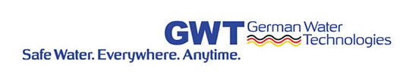
Protoplan develops and sells solar powered solutions for decentralized drinking water disinfection. Fossil powered water stations can be replaced by the INTEWA system in order to decrease the energy demand. Especially in institutions such as hospitals, schools and hotels Protoplan technologies suit very well.

Website: http://www.germanwatertechnologies.de/

Schuntermann Transformatoren GmbH:
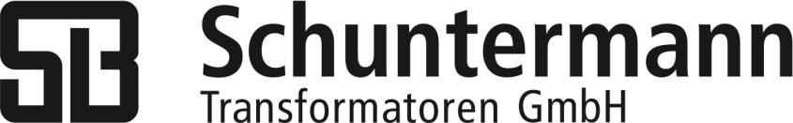
Schuntermann has been manufacturing and installing components and systems for the control and stabilization of voltages and currents for a number of decades. The owner-managed company in its third generation boasts a highly specialized team of advisors for customer-oriented solutions. Under its own brand RENECOST®, the company has been producing and marketing systems for reducing power consumption, power costs and CO2 emissions for more than two decades. Schuntermann manufactures all of its products at its site in Hilden, Germany and from there serves the domestic and international market.
Website: http://www.schuntermann.de/company/?lang=en

